ASSIGNMENT – I

DOMAIN:IOT

TITLE:SMART HOME

1. Make a Smart Home in Tinkercad, using 2+ sensors, Led, Buzzer in single code and circuit.

SMART Home Circuit Connection:
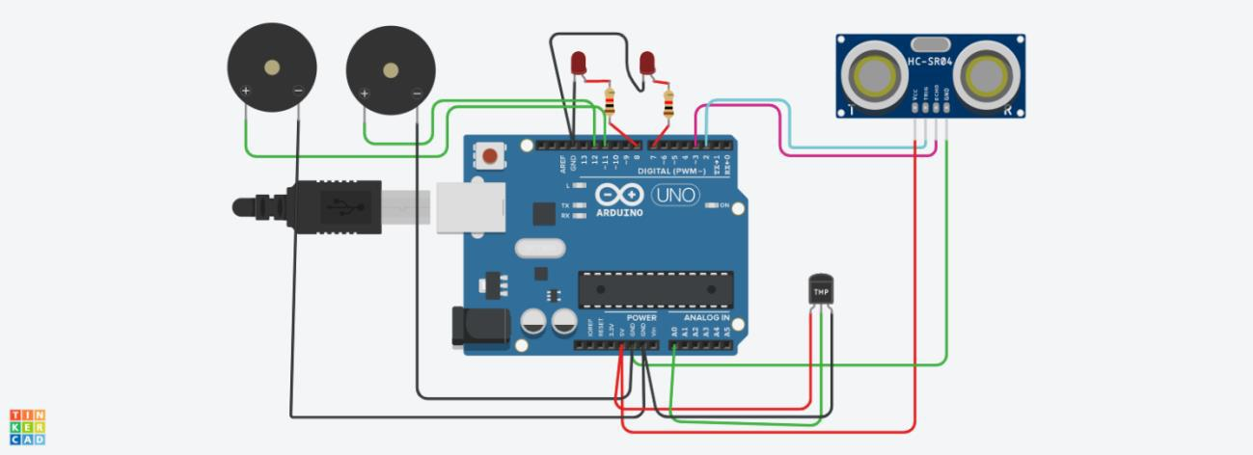

Components Used:

i)2 Piezo Buzzers

ii)Temperature Sensor

iii)Ultrasonic Sensor

iv)LED -2

v)Resistor-2

Code :

int t=2;

int e=3;

void setup()

{

Serial.begin(9600);

pinMode(t,OUTPUT);

pinMode(e,INPUT);

pinMode(12,OUTPUT);

}

void loop()

{

//ultrasonic sensor

digitalWrite(t,LOW);

digitalWrite(t,HIGH);

delayMicroseconds(10);

digitalWrite(t,LOW);

float dur=pulseIn(e,HIGH);

float dis=(dur*0.0343)/2;

Serial.print("Distance is: ");

Serial.println(dis);

//LED ON

if(dis>=100)//(in terms of centimeter)

{

digitalWrite(8,HIGH);

digitalWrite(7,HIGH);

}

//Buzzer For ultrasonic Sensor

if(dis>=100)

{

for(int i=0; i<=30000; i=i+10)

{

tone(12,i);

delay(1000);

noTone(12);

delay(1000);

}

}

//Temperate Sensor

double a= analogRead(A0);

double t=(((a/1024)*5)-0.5)*100;

Serial.print("Temp Value: ");

Serial.println(t);

delay(1000);

//LED ON

if(t>=100)//(in terms of celsius)

{

digitalWrite(8,HIGH);

digitalWrite(7,HIGH);

}

/Buzzer for Temperature Sensor

if(t>=100)

{

for(int i=0; i<=30000; i=i+10)

{

tone(12,i);

delay(1000);

noTone(12);

delay(1000);

}

}

//LED OFF

if(t<100)

{

digitalWrite(8,LOW);

digitalWrite(7,LOW);

}

}

